 | Yankee Clipper  Mermaid Munster Championship 2023  Sat 3rd & Sun 4th June | 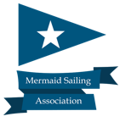
 | Venue & Organising Authority:  Foynes Yacht Club  NOTICE OF RACE | 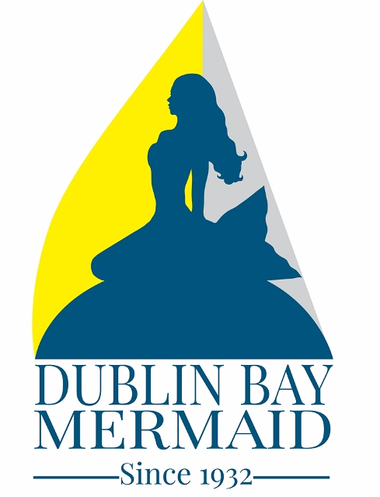
There will be 4 Races sailed as detailed in the schedule below of which a minimum of one race shall constitute a championship.
RULES
This event shall be governed by The Racing Rules of Sailing (RRS 2021-2024), the prescriptions of the Irish Sailing Association (ISA), the MSA Class rules and the Sailing Instructions.

All those taking part in this event do so at their own risk and responsibility. The organisers shall not be responsible for the seaworthiness of a boat whose entry is accepted or for the sufficiency or adequacy of its equipment. The organisers shall not be responsible or liable for any injury to persons or damage to property either ashore or afloat which may result from participation or intended participation in this event.

ENTRIES
Entries shall be submitted to FYC with Entry fee of €50. Entry forms will be available during Registration at Foynes Yacht Club from 9-10am on Saturday the 3rd June. If you wish to enter in advance of the event, please contact Foynes Class Captain Mark Mc Cormack 087 7175455

A Championship Briefing will take place in FYC Clubhouse at 1000 hrs on Saturday the 3rd June.

SCHEDULE OF RACES

Date HW LW Warning Gun Number of Races
Saturday 3rd 06:05 (4.8m) 12:07 (0.5m) 11:00 hrs 3
Sunday 4th 06:49 (4.9m) 12:50 (0.5m) 11:30 hrs 1

On Saturday there will be as little delay as possible between races and each new race sequence will be started as quickly as possible. Races will aim to be approx. 50 minutes long on Saturday.

LAUNCHING – There is very restricted windows for launching There will be a launching tractor operating from 7-8pm on Friday the 2nd June to encourage boats to get in the water Friday, there will be berths available so please bring fenders with you. Please get your boat launched as early as possible.

If you don’t get launched on Friday there will be launching from 8:30am – 10:00am on Saturday the 3rd.

DISCARDS - A minimum of one race will constitute a championship. If one, two or three races are sailed, there will be no discard. If 4 races are sailed there will be one discard.

PRIZES - Prizes for the event will be awarded for 1st, 2nd, and 3rd place overall if there are ten boats or more entered. Prizes will be presented on Sunday 4th after racing in the clubhouse.

ENTERTAINMENT - A buffet dinner will be served at the clubhouse on Saturday the 3rd and will be followed by live music till 11.30pm. Complimentary cereal, toast, tea and coffee will be provided in the mornings. We look forward to seeing as many local and visiting Mermaids as possible at FYC for this festival event.

Enjoy the sailing!

Bev Lowes Mark Mc Cormack
Commodore – Foynes Yacht Club Foynes Mermaid Class Captain
Mobile: 086 6090532 Mobile: 087 7175455

COVID-19 Notice

This event is subject to the Covid 19 guidelines as laid out by the Irish Government. All people associated with this event must comply with these conditions. These conditions may change as the event approaches and will influence the running/organisation/cancellation of this event.
The OA will monitor the novel coronavirus (COVID-19) pandemic or other potential disruptions to the event and having regard for the health and safety of all participants, as well as any government travel restrictions or government mandated conditions on gatherings that affect participation in or conduct of the Event, may at its sole discretion.
a) Cancel the Event, reject or cancel entries at its absolute discretion,
b) Restrict the entries from a region,
c) Make any other decision deemed necessary in the
circumstances,
d) Refund the entry fee in full should the OA cancel or
reject an entry.

